-- Create Sales Table with additional columns

CREATETABLESales (

SaleIDINTPRIMARYKEY,

SaleDateDATE,

SaleAmountDECIMAL(10,2),

SalespersonVARCHAR(100),

RegionVARCHAR(50)

);

-- Insert Data into Sales Table with duplicates

INSERTINTOSales (SaleID,SaleDate,SaleAmount,Salesperson,Region)VALUES (1,'2024-09-01',500.00,'Alice','North');

INSERTINTOSales (SaleID,SaleDate,SaleAmount,Salesperson,Region)VALUES (2,'2024-09-02',1500.00,'Bob','West');

INSERTINTOSales (SaleID,SaleDate,SaleAmount,Salesperson,Region)VALUES (3,'2024-09-03',750.00,'Charlie','North');

INSERTINTOSales (SaleID,SaleDate,SaleAmount,Salesperson,Region)VALUES (4,'2024-09-04',1200.00,'Alice','East');

INSERTINTOSales (SaleID,SaleDate,SaleAmount,Salesperson,Region)VALUES (5,'2024-09-05',500.00,'Bob','North');

INSERTINTOSales (SaleID,SaleDate,SaleAmount,Salesperson,Region)VALUES (6,'2024-09-06',1500.00,'Charlie','West');

INSERTINTOSales (SaleID,SaleDate,SaleAmount,Salesperson,Region)VALUES (7,

'2024-09-07',1200.00,'Alice','East');

-- Query using ROW_NUMBER()

SELECT

ROW_NUMBER()OVER (ORDERBYSaleAmountDESC)ASRowNum,

SaleID,

SaleDate,

SaleAmount,

Salesperson,

Region

FROMSales;

-- Query using RANK()

SELECT

RANK()OVER (ORDERBYSaleAmountDESC)ASRank,

SaleID,

SaleDate,

SaleAmount,

Salesperson,

Region

FROMSales;

-- Query using DENSE_RANK()

SELECT

DENSE_RANK()OVER (ORDERBYSaleAmountDESC)ASDenseRank,

SaleID,

SaleDate,

SaleAmount,

Salesperson,

Region

FROMSales;

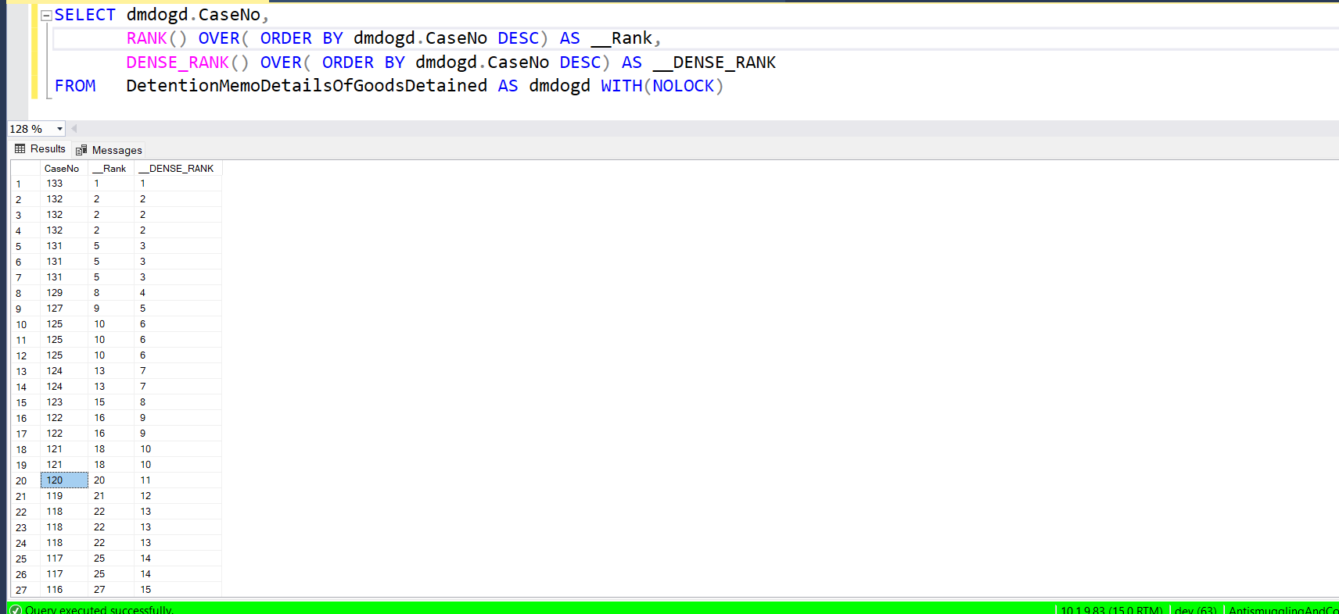

SELECTSaleAmount

FROM (

SELECT

SaleAmount,

row_number()OVER (ORDERBYSaleAmountDESC)ASRowNum

FROMSales

)ASranked_salaries

WHERERowNum=2;

SELECTSaleAmount

FROM (

SELECT

SaleAmount,

rank()OVER (ORDERBYSaleAmountDESC)ASRowNum

FROMSales

)ASranked_salaries

WHERERowNum=2;

SELECTSaleAmount,SaleID

FROM (

SELECT

SaleID,

SaleAmount,

dense_rank()OVER (ORDERBYSaleAmountDESC)ASRowNum

FROMSales

)ASranked_salaries

WHERERowNum=2;

SELECT

SaleID,

SaleAmount,

DENSE_RANK()OVER (PARTITIONBYSaleAmountORDERBYSaleIDdesc)ASRowNum

FROMSales